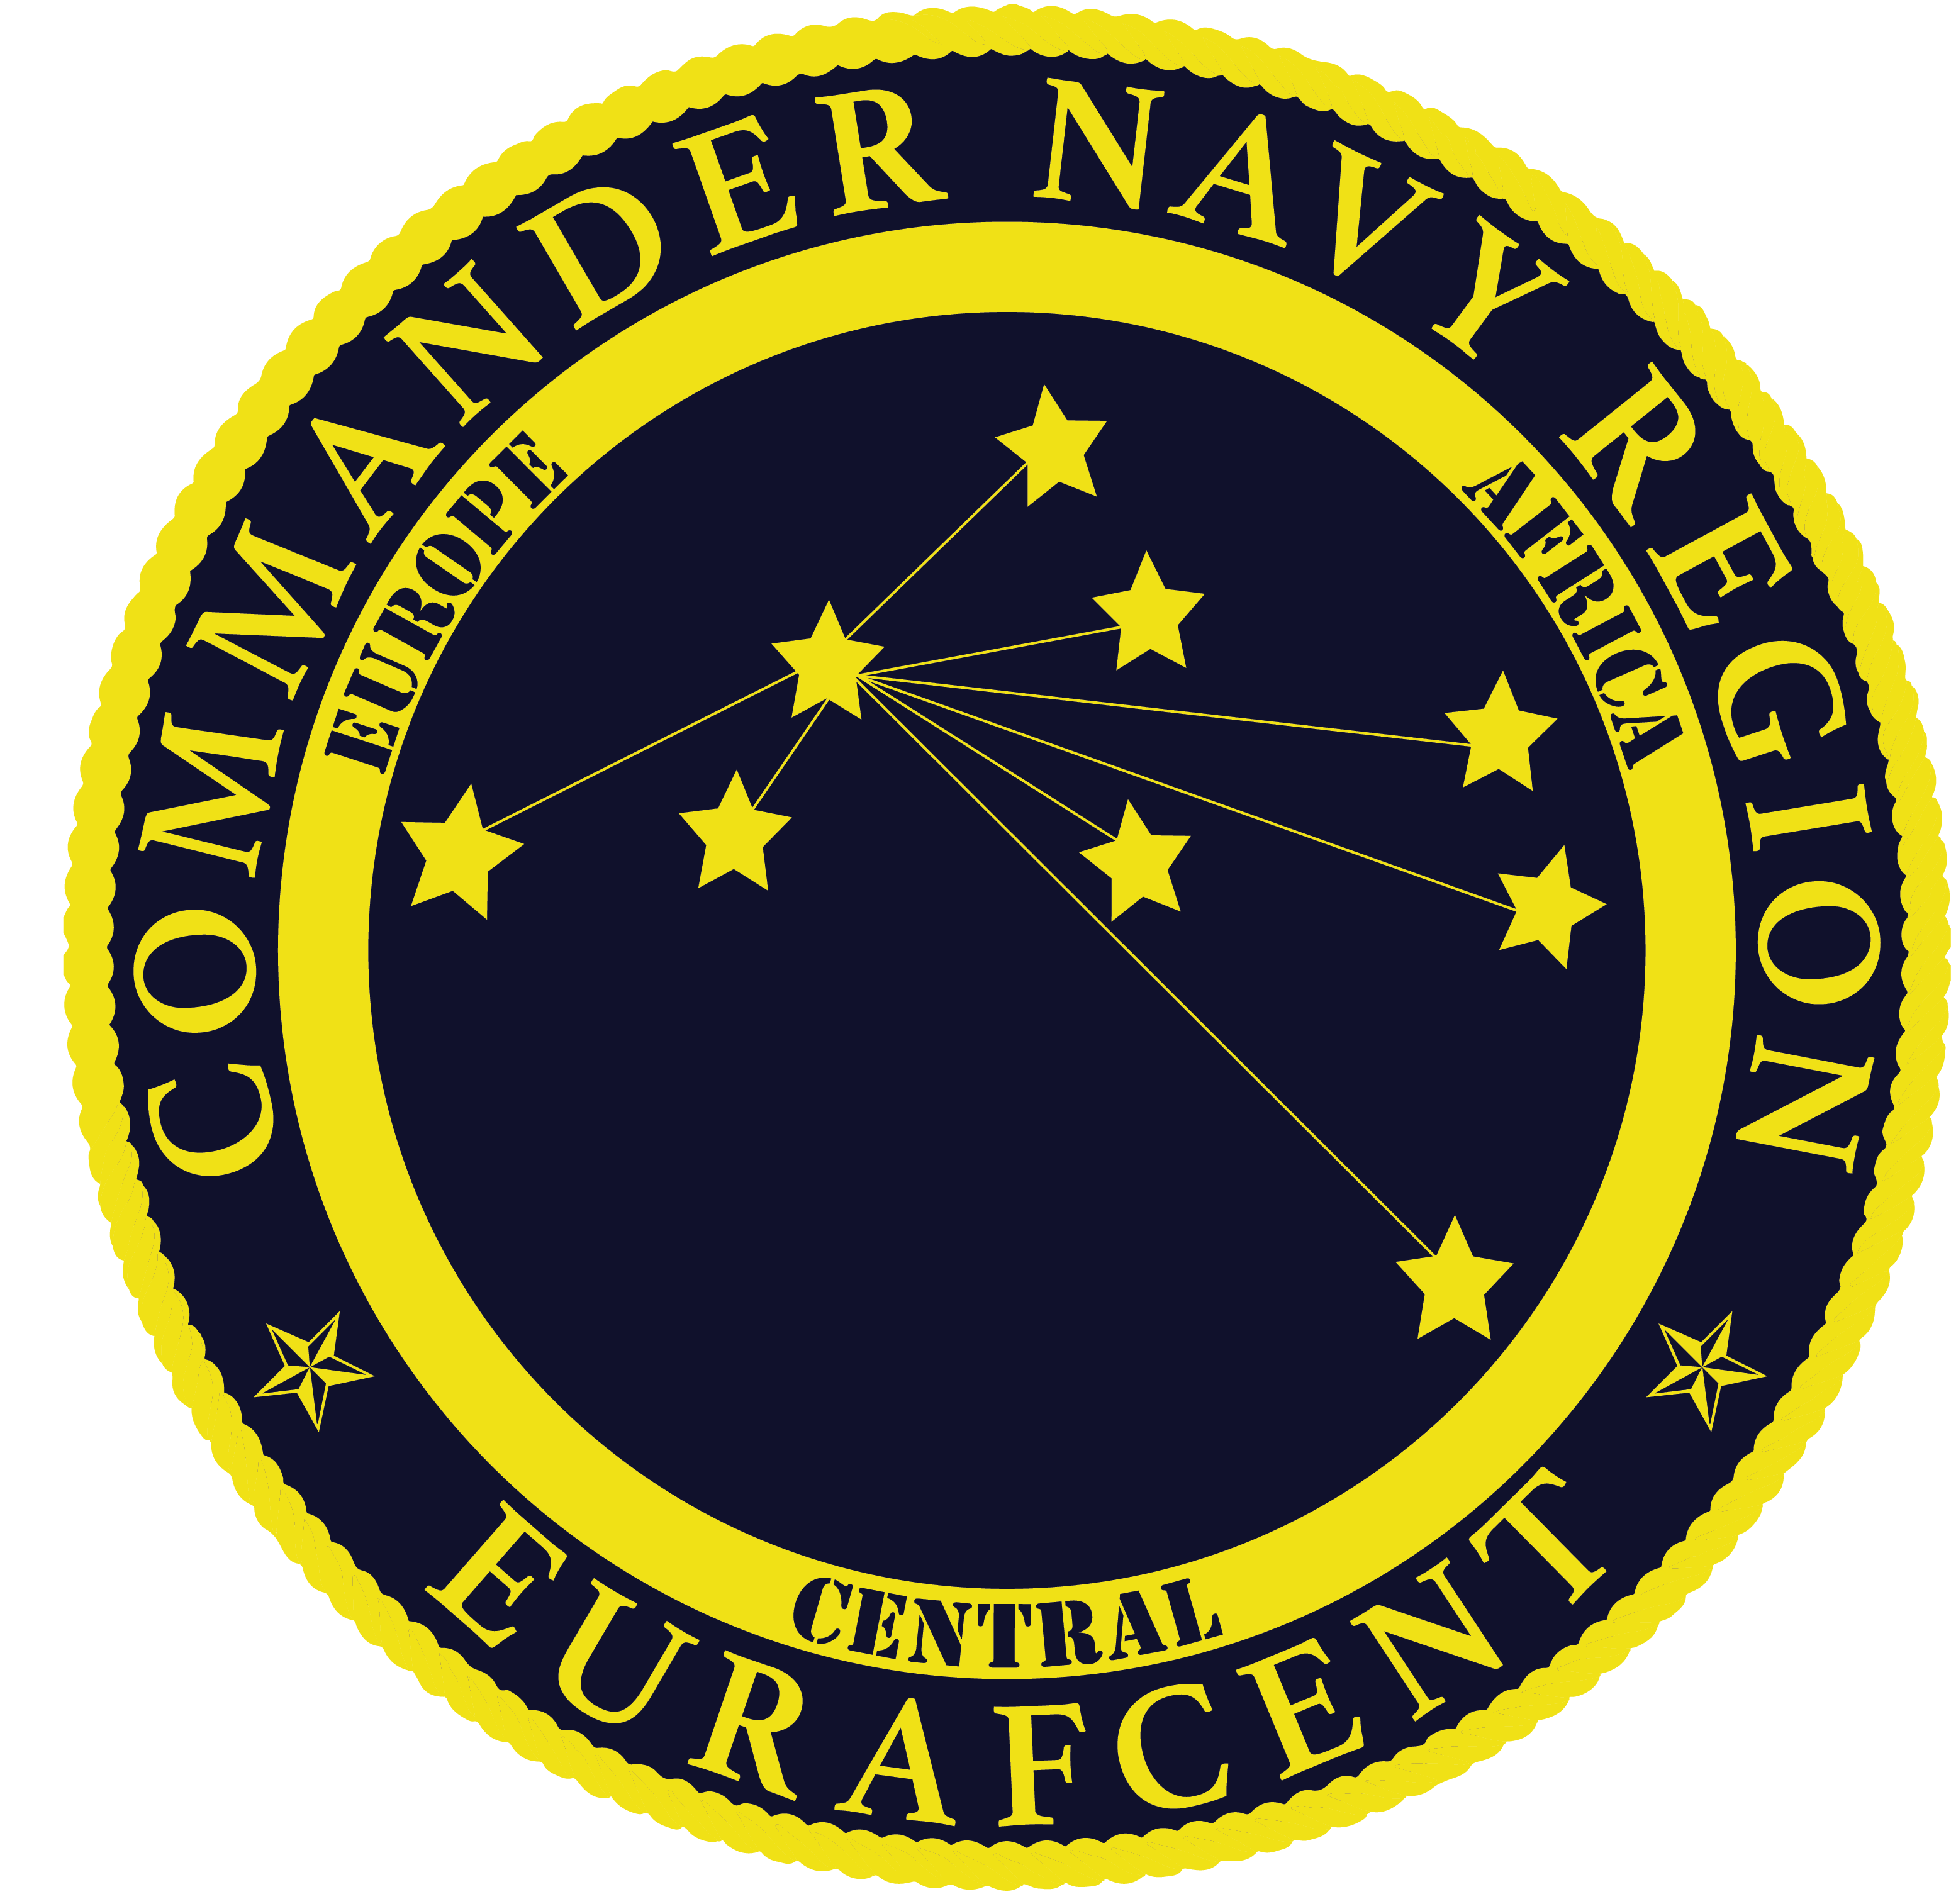
Navy Region Europe, Africa, Central
NAF Human Resources
PSC 817 BOX 108
FPO, AE 09622-0108
NAFPersonnel@eu.navy.mil

VACANCY ANNOUNCEMENT
NON-APPROPRIATED FUND (NAF) POSITION
AMENDED SALARY RANGE UPDATE

ANNOUNCEMENT NO. | EUR21-111R
POSITION TITLE | CYP Custodian  NA 3566 02
SALARY | $9.98-$11.65 PH
EMPLOYMENT CATEGORY | Regular Full-time
LOCATION | Commander, Navy Region Europe; Fleet and Family Readiness Program; Morale, Welfare & Recreation (MWR);
LOCATION | Child & Youth Programs (CYP); NSA Naples CYP - SAC
AREA OF CONSIDERATION | Local U.S. Citizens that are 1) Current permanent NAF/APF employees; or 2) Spouses of active duty military members; or  3) Family members of active duty military member; or 4) Family members of DoD civilians.

“The NATO Status of Forces Agreement (SOFA) between Italy and the United States prohibits the hiring of any person who holds Italian citizenship and is considered a Dual National by the Italian Government into any U.S. position. Those U.S. citizens who are considered “ordinarily resident” in Italy are also ineligible for employment by U.S. commands and activities in Italy.”

INTRODUCTION
This announcement is for the CYP custodian at NSA Naples.

DUTIES AND RESPONSIBILITIES
All custodial and housekeeping services will be performed according to the established specifications. Child and youth routines will not be disturbed by custodial activities. Some of the daily cleaning services will take place when programs are not in operation and children and youth are not present. The CYP custodian has responsibilities related to cleaning and to the use and maintenance of equipment and supplies. These tasks are summarized below.

Cleaning Requirements

Sweeps, mops, strips, scrubs, waxes, polishes floors and cleans carpets.

Wipes mirrors, metal doorplates, bathroom and kitchen fixtures, and all metal fittings.

Cleans showcases, entrance doors, activity spaces/classrooms, doorframes and switches, paper towel dispensers, and other surfaces as required.

Cleans glass partitions, inside and outside windows, and uses stepladders and extension ladders to change light bulbs, replace blinds, and wash walls.

Dusts, waxes and polishes furniture. Dusting furniture, equipment, and surfaces will not be done within the reach of children.

Empties and washes trashcans.

Inspects grounds, including removing trash and debris, and notifies supervisor of safety hazards.

Maintains restrooms in a clean, orderly and sanitary condition. Cleans, disinfects and deodorizes lavatories. Replaces deodorizers, toilet tissues, hand towels, and soap. Reports water leaks, clogged drains and other conditions requiring repairs to supervisor.

Sweeps sidewalks and parking lots.

Use and Maintenance of Equipment and Supplies

Operates powered cleaning equipment, cleans and oils equipment, and changes brushed and accessories.

Maintains cleaning supplies and advises supervisor when supplies are needed or when equipment needs repairs or replacement. All custodial equipment, supplies and materials will be approved by the health consultant or safety officer.

Ensures that hallways, stairways, entrances, and doorways are not obstructed by any cleaning or maintenance operations or storage of equipment and materials.

Stores custodial supplies and equipment properly in locked cabinets or closets away from child and youth activity rooms.

Loads and unloads merchandise, equipment and supplies.

Assembles equipment.

May be required (less than 10% of the time) to deliver merchandise, equipment and supplies to other locations.

Additional Responsibilities

May be required to move, set-up and/or rearrange furniture, as well as, set-up and break-down for special events.

Responsible for complying with security, fire and sanitation rules, policies, procedures, and regulations.

Serves as a mandatory reporter to Family Advocacy and Child Protective Services as prescribed by local policy in the case of suspected incidences of child abuse and neglect.

Performs other duties as assigned.

QUALIFICATIONS & REQUIREMENTS
Must be a U.S. citizen.

BENEFITS: A comprehensive benefits package is available.

HOW TO APPLY: Interested applicants may apply online at www.USAJOBS.gov. Emailed resume packages will NOT be accepted for this position. For the full announcement and to apply, visit https://www.usajobs.gov/GetJob/ViewDetails/593946100?t=1614766746759

Only resumes submitted according to the instructions on the job announcement listed at www.usajobs.gov will be considered.

The Department of Navy (DON) is an Equal Employment Opportunity Employer. All qualified candidates will receive consideration without regard to race, color, religion, sex, national origin, age, disability, marital status, political affiliation, sexual orientation, genetic information or any other non-merit factor. The DON provides reasonable accommodation to applicants with disabilities. Applicants with disabilities who believe they require reasonable accommodation should call 011-39-081-568-5612 or e-mail their request to NAFPersonnel@eu.navy.mil to ensure proper consideration. The decision to grant an accommodation will be made on a case-by-case basis.

