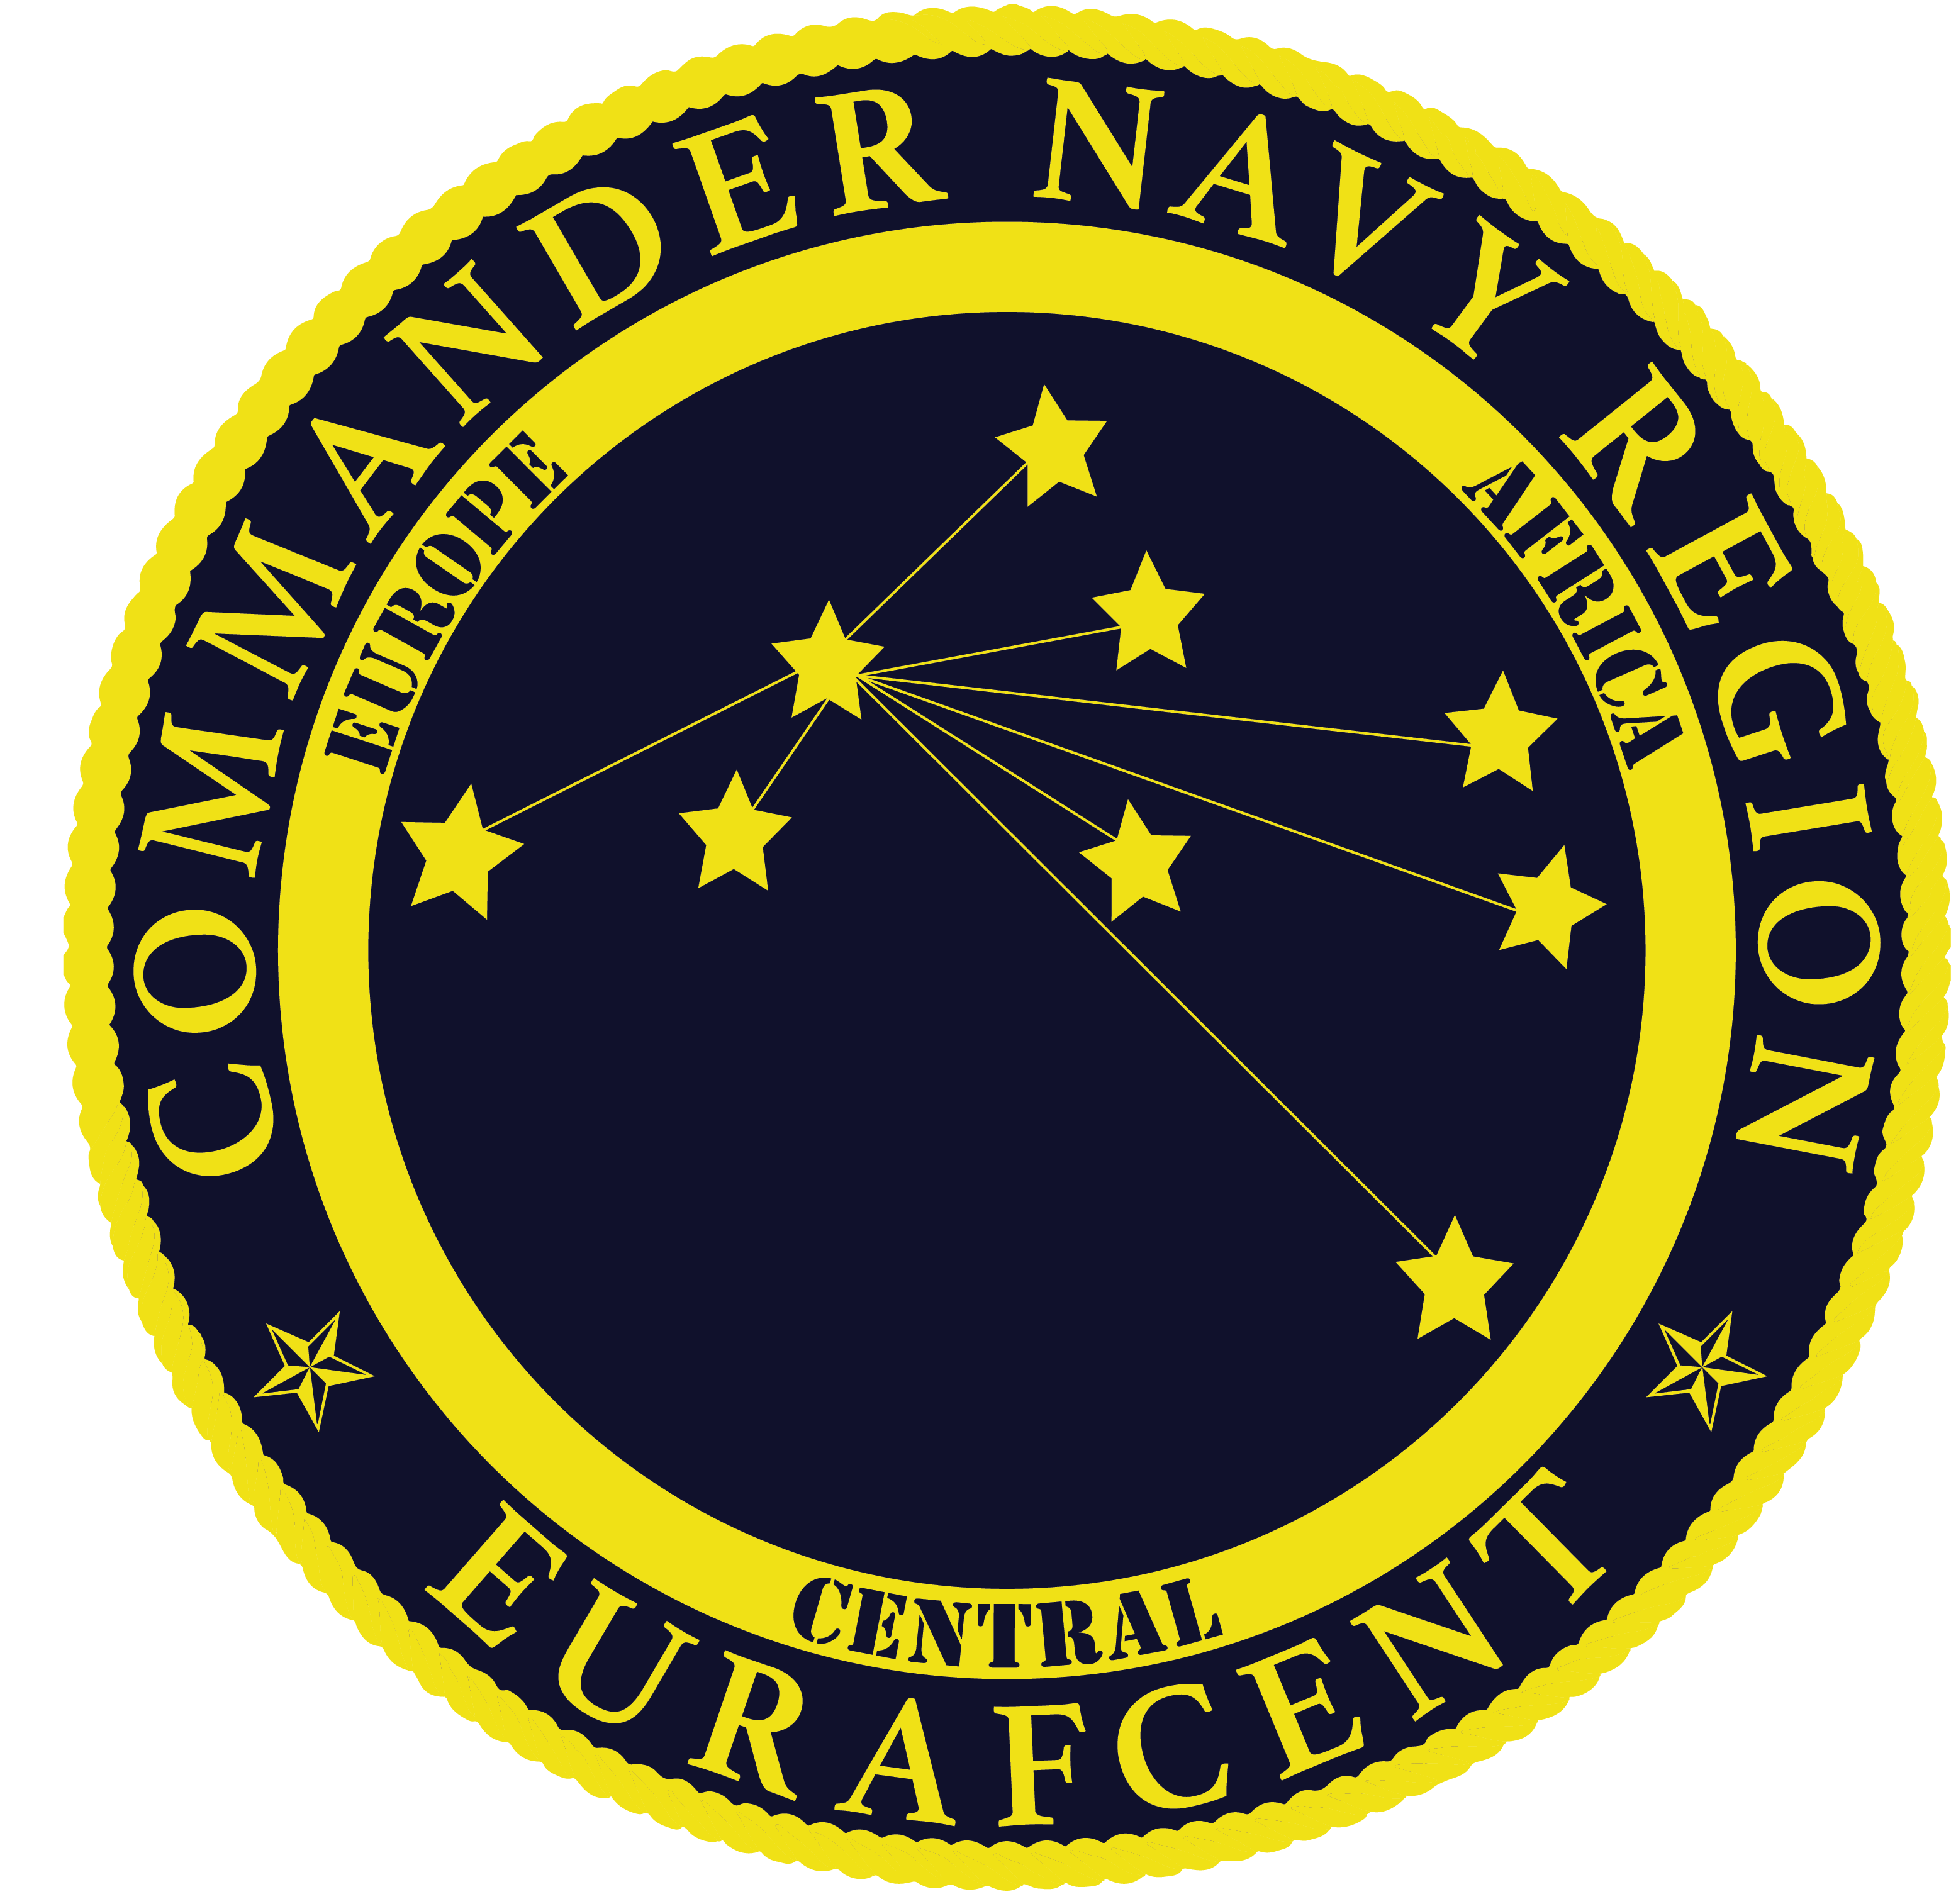
Navy Region Europe, Africa, Central
NAF Human Resources
PSC 817 BOX 108
FPO, AE 09622-0108
NAFPersonnel@eu.navy.mil

VACANCY ANNOUNCEMENT
NON-APPROPRIATED FUND (NAF) POSITION
AMENDED SALARY RANGE UPDATE

ANNOUNCEMENT NO. | EUR21-002R1
POSITION TITLE | CYP Assistant – Entry/Intermediate/Target
SALARY | $12.23 - $16.76 per hour
EMPLOYMENT CATEGORY | Regular Part-Time (20-34 Hours per week)
LOCATION | Commander, Navy Region Europe; Fleet and Family Readiness Program; Morale, Welfare & Recreation (MWR);
LOCATION | Child & Youth Program (CYP); NSA Naples
AREA OF CONSIDERATION | Local U.S. Citizens that are 1) Current permanent NAF/APF employees; or 2) Spouses of active duty military members; or 3) Family members of active duty military member; or 4) Family members of DoD civilians.
Note: The NATO Status of Forces Agreement (SOFA) between Italy and the United States prohibits the hiring of any person who holds Italian citizenship and is considered a Dual National by the Italian Government into any U.S. position. Those U.S. citizens who are considered “ordinarily resident” in Italy are also ineligible for employment by U.S. commands and activities in Italy.

INTRODUCTION: Fleet and Family Readiness is looking for the best and brightest to join our TEAM! The Navy team offers innovative, exciting and meaningful work linking military and civilian talents to achieve our mission and safeguard our freedoms by enhancing the quality of life for Sailors, their families, and others in the Navy Community. Department of the Navy provides competitive salaries, comprehensive benefits, and extensive professional development and training.

Child and Youth Programs (CYP) are responsible for providing safe, happy and nurturing care for children. Navy Child and Youth Programs provide high quality educational and recreational programs for children and youth. Teams of caring, knowledgeable professionals plan developmentally appropriate programs that are responsive to the unique needs, abilities, and interests of children. Our staff fosters a sense of independence, trust, and responsibility within each child through understanding and respectful interactions. Likewise, through positive relationships, our programs respect and support the ideals, cultures, and values of families in their task of nurturing children and youth. We are advocates for children, families, and the child and youth professionals within our programs and surrounding communities.

The purpose of the CYP Assistant is to provide appropriate developmental care and instruction for children and youth ranging in age from 6 weeks to 18 years in one or more CY programs.

MAJOR DUTIES AND RESPONSIBILITIES: The duties and responsibilities of the CY Program Assistant have been grouped into categories, including curriculum, indoor and outdoor environment, interactions and relationships, supervision of children and youth, parent and employee communication, assessment, compliance, and additional responsibilities. Each is described below.

Curriculum: Assists in planning and coordinating activities for program participants, including group as well as individual activities. Implements daily schedules and activity plans to ensure age and/or stage appropriateness. Incorporates special instructions provided by parents such a special dietary needs, physical needs, or other information that may affect the child or youth's experience in the program. Assists children and youth with special projects and homework. Cares for children and youth with special needs as directed by the supervisor. Promotes and models safety, fitness, health, and nutrition practices. Helps arrange for and/or serve appropriate snacks or meals where applicable.

Indoor and Outdoor Environment: Helps prepare, arrange, and maintain indoor and outdoor activity areas and materials to accommodate daily schedule. Sets up displays and bulletin boards. Inventories equipment on a recurring basis and recommends replenishing damaged, missing, and depleted supplies. Secures supplies, equipment, and facilities.

Interactions and Relationships: Establishes a program environment that sustains participant interest and promotes positive interactions with other children, youth, and adults. Interacts with children and youth using approved child guidance and youth development techniques.

Supervision of Children and Youth: Provides care and supervision, oversight, and accountability for program participants in compliance with the Department of Defense (DoD), NAF Component, and local installation policies, guidance, and standards. Maintains control of and accounts for whereabouts and safety of children and youth ranging in age from 6 weeks to 18 years. Ensures children and youth (as applicable) depart with authorize person according to written parental instructions. Supervises children and youth during daily schedule of indoor and outdoor activities, on field trips, outings, and special events. Observes program participants for signs that may indicate illness, abuse, or neglect and reports as directed. A mandatory reporter to Family Advocacy and Child Protective Services as prescribed by local policy in the case of suspected incidences of child abuse and neglect.

Parent and Employee Communication: Interacts professionally with employees, parents, and local installation command personnel. Participates in conferences with parents and employees.

Assessment: Participates in program evaluation using designated instruments such as programmatic rating scales, risk assessment tools (as required), self-inspection materials, and national accreditation tools.

Compliance: Assists in achieving and maintaining DoD certification and national accreditation or equivalent. Ensures compliance with law, policies, and regulations applicable to DoD CY programs. Notifies supervisor of health, fire, and safety compliance concerns.

Additional Responsibilities: Collects, maintains, and reports program participation data.

QUALIFICATION REQUIREMENTS: Must be at least 18 years of age and possess a high school diploma or equivalent.

To qualify at ENTRY level ($12.23 - $13.25 per hour):
Prior experience working with children and/or youth preferred.

To qualify at INTERMEDIATE Level ($13.79 - $14.93 per hour):
Have six (6) months experience working with children or youth in a child or youth setting.
AND
Have completed child abuse modules and modules 1, 2, and 10 of the DoN Standardized Module Training.

To qualify at TARGET Level ($15.48 - $16.76 per hour):
Completion of the DoN Standardized Module Training AND 12 months of experience working with children and youth.
OR
A Child Development Associate (CDA) credential or Military School-Age (MSA) credential.
OR
2-year degree in Early Childhood Education (ECE), Child Development or related field of study, which can include Youth Recreation, Physical Education, Elementary Education, Secondary Education, Youth Development, Psychology, Social Work, Home Economics with an emphasis in Human Development, or other degrees as appropriate.

KNOWLEDGE REQUIRED BY THE POSITION: Ability to communicate effectively in English, both orally and in writing. Ability to follow verbal and written instructions. Ability to complete all DoN training requirements within the specified time frames, including orientation, initial, Standardized Module Training, and ongoing training requirements. Ability to promote and foster effective working relationships with children and youth and coworkers. Ability to work cooperatively as a member of a team.

CONDITIONS OF EMPLOYMENT: Position is subject to special inoculation and immunization requirements as a condition of employment for working with children. Employee is required to obtain appropriate immunization against communicable diseases in accordance with recommendations from the Advisory Committee on Immunization Practices (ACIP), which includes the influenza vaccine.

In accordance with the Department of the Navy Test Designated Position listing issued 7 October 2003 this position is subject to both pre-employment and random drug testing as a condition of employment. A positive drug test, or failure to submit for testing, may become the basis for removal from this position.

Must pass a pre-employment physical, provide evidence of immunization and be free from communicable disease.

Must satisfactorily obtain or complete required training certificates and maintain certifications or credentials required by federal, state or National Accreditation institutions utilized as part of DOD’s Child and Youth Programs.

Incumbent must satisfactorily complete all background checks for federal childcare positions, including a National Agency Check with Inquiries (NACI), criminal history checks to include fingerprints, and installation record checks.

Incumbents will be automatically disqualified for a conviction (either civilian or military to include any general, special or summary court-martial or non-judicial punishment) for a sexual offense, a felony drug offense, or any criminal offense involving a child victim. Automatic disqualification also applies if the incumbent has been found negligent in a civil adjudication or administrative proceeding concerning the death or serious injury to a child or dependent person entrusted to the individual’s care.

All selections are contingent upon satisfactory employment reference checks.

BENEFITS: A comprehensive benefits package is available.

HOW TO APPLY: Interested applicants may apply online at www.USAJOBS.gov. Emailed resume packages will NOT be accepted for this position. For the full announcement and to apply, visit http://www.usajobs.gov/GetJob/ViewDetails/585814000?t=1606832596788

Only resumes submitted according to the instructions on the job announcement listed at www.usajobs.gov will be considered.

The Department of Navy (DON) is an Equal Employment Opportunity Employer. All qualified candidates will receive consideration without regard to race, color, religion, sex, national origin, age, disability, marital status, political affiliation, sexual orientation, genetic information or any other non-merit factor. The DON provides reasonable accommodation to applicants with disabilities. Applicants with disabilities who believe they require reasonable accommodation should call 011-39-081-568-5612 or e-mail their request to NAFPersonnel@eu.navy.mil to ensure proper consideration. The decision to grant an accommodation will be made on a case-by-case basis.

