Banned Books Week: Oct. 6-11
QUIZ

Censorship is so 1984. Read for your rights!
Why Were These Books Banned?

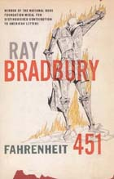 | Fahrenheit 451  by: Ray Bradbury  _______________________  _______________________  _______________________  _______________________
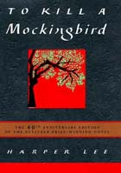 | To Kill a Mockingbird  by: Harper Lee  _______________________  _______________________  _______________________  _______________________
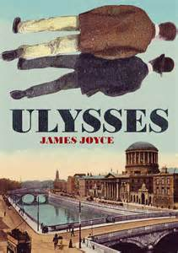 | Ulysses  by: James Joyce  _______________________  _______________________  _______________________  _______________________
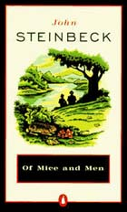 | Of Mice and Men  by: John Steinbeck  _______________________  _______________________  _______________________  _______________________
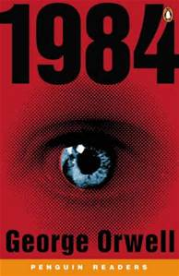 | 1984  by: George Orwell  _______________________  _______________________  _______________________  _______________________
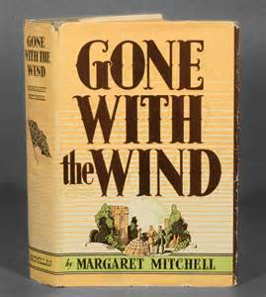 | Gone with the Wind  by: Margaret Mitchell  _______________________  _______________________  _______________________  _______________________
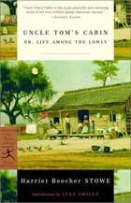 | Uncle Tom's Cabin  by: Harriet Beecher Stowe  _______________________  _______________________  _______________________  _______________________
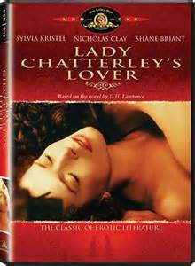 | Lady Chatterley’s Lover  by: D. H. Lawrence  _______________________  _______________________  _______________________  _______________________
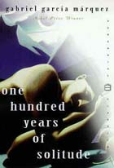 | One Hundred Years of Solitude  by: Gabriel García Márquez  _______________________  _______________________  _______________________  _______________________



Name ___________________________ Age____________

Ph. _________________ Email: ___________________________

