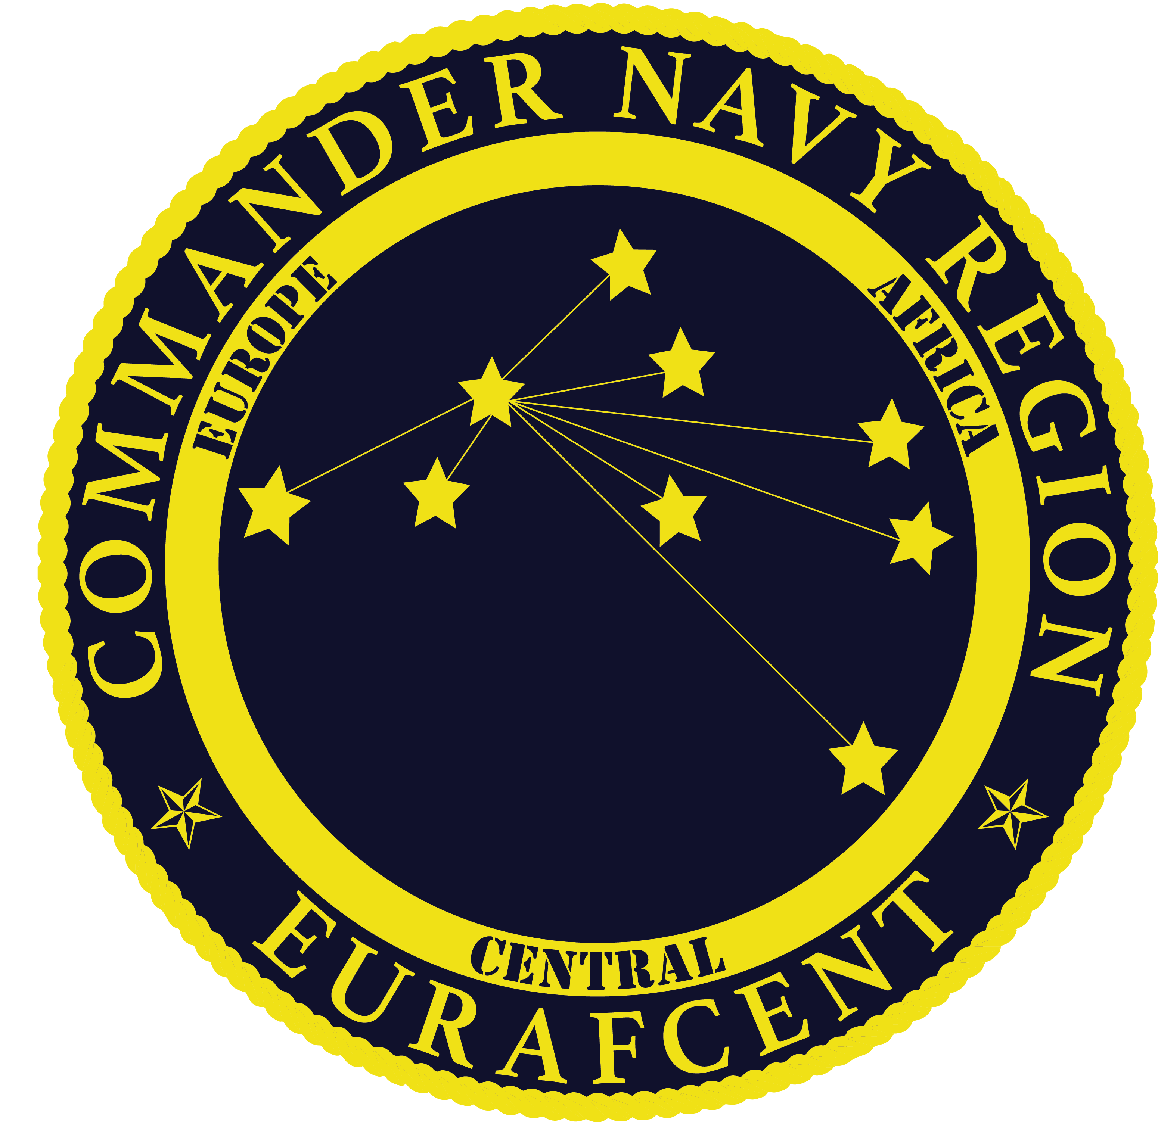
Navy Region Europe, Africa, Central
NAF Human Resources
PSC 817 BOX 108
FPO, AE 09622-0108
NAFPersonnel@eu.navy.mil

VACANCY ANNOUNCEMENT
NON-APPROPRIATED FUND (NAF) POSITION
AMENDED SALARY UPDATE

ANNOUNCEMENT NO. | EUR22-061
POSITION TITLE | BARTENDER, NA-7405-04
SALARY | $17.25 per hour
EMPLOYMENT CATEGORY | Flexible
LOCATION | Commander, Navy Region Europe; Fleet and Family Readiness Program; Morale, Welfare & Recreation (MWR);
LOCATION | Orys Pub
AREA OF CONSIDERATION | Local U.S. Citizens that are 1) Current permanent NAF/APF employees; or 2) Spouses of active duty military members; or  3) Family members of active duty military member; or 4) Family members of DoD civilians
OPENING DATE | 17 FEBRUARY 2022
CLOSING DATE | 17 MARCH 2022

Note: The NATO Status of Forces Agreement (SOFA) between Italy and the United States prohibits the hiring of any person who holds Italian citizenship and is considered a Dual National by the Italian Government into any U.S. position. Those U.S. citizens who are considered “ordinarily resident” in Italy are also ineligible for employment by U.S. commands and activities in Italy.

INTRODUCTION: This position is located in Orys Pub at the Bowling Center of Morale, Welfare & Recreation Department, Naval Support Activity, Naples, Italy. The incumbent is responsible for mixing and serving of alcoholic and nonalcoholic beverages.

MAJOR DUTIES AND RESPONSIBILITIES: Mix and serve a wide variety of alcoholic and nonalcoholic beverages from a full service bar following standard recipes. Receive and record payment at time of sale. Maintain the bar in a presentable and sanitary condition. Count change funds and cash receipts. Complete a Daily Activity Report. Total cash receipts, complete applicable forms and deposit in night depository. May provide technical guidance to Bar Assistants. The primary purpose of the MWR Department is to provide programs and services, which will contribute to the enhancement of morale and professional cohesiveness of the military community. Toward achievement of these ends, a positive perception by patrons of attitude, spirit of commitment of personnel policies and procedures by personnel of the Department is primary.

QUALIFICATION REQUIREMENTS: Must be 21 years of age. Must possess the skill and knowledge to mix and serve a wide variety of alcoholic and nonalcoholic beverages by combining ingredients such as liquors, soda, water, sugar, bitters and fruit garnishes. Also serves liqueur, beer and wine and possesses the skill in mixing beverages. Must possess the ability to completely set up a bar and recognize the impeding shortages of supplies based on volume of business to ensure their timely replacement. Must be able to proficiently and accurately handle a large volume of cash. Must be able to qualify for a health card issued by the Department of the Navy. Must be able to qualify for and successfully complete sanitation school.

CONDITIONS OF EMPLOYMENT: Incumbent must satisfactorily complete a National Agency Check (NACI). To ensure compliance with an applicable preliminary nationwide injunction, which may be supplemented, modified, or vacated, depending on the course of ongoing litigation, the Federal Government will take no action to implement or enforce the COVID-19 vaccination requirement pursuant to Executive Order 14043 on Requiring Coronavirus Disease 2019 Vaccination for Federal Employees. Therefore, to the extent a Federal job announcement includes the requirement that applicants must be fully vaccinated against COVID-19 pursuant to Executive Order 14043, that requirement does not currently apply. Federal agencies may request information regarding the vaccination status of selected applicants for the purposes of implementing other workplace safety protocols, such as protocols related to masking, physical distancing, testing, travel, and quarantine.

All selections are contingent upon satisfactory employment reference checks.

HOW TO APPLY: Interested applicants may apply via emailed resume package to https://www.usajobs.gov/job/637915100?t=1645110138634

The Department of Navy (DON) is an Equal Employment Opportunity Employer. All qualified candidates will receive consideration without regard to race, color, religion, sex, national origin, age, disability, marital status, political affiliation, sexual orientation, genetic information or any other non-merit factor. The DON provides reasonable accommodation to applicants with disabilities. Applicants with disabilities who believe they require reasonable accommodation should call 011-39-081-568-5612 or e-mail their request to NAFPersonnel@eu.navy.mil to ensure proper consideration. The decision to grant an accommodation will be made on a case-by-case basis.

