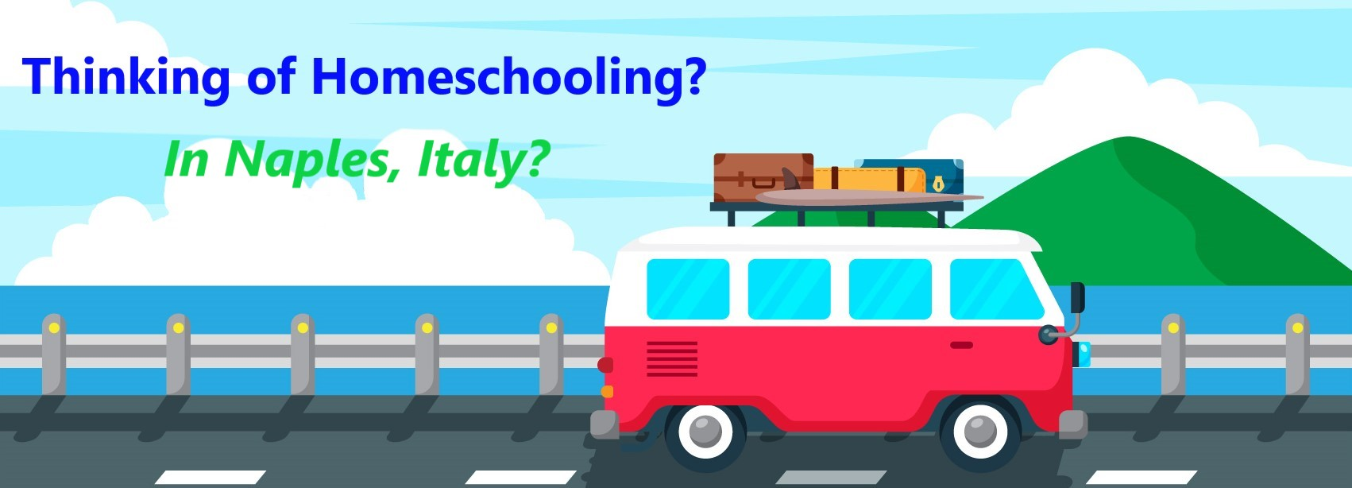

**What is homeschooling?**

Homeschooling is the practice of opting to teach your own children at home via parents, tutors or virtual programs instead (or in lieu) of sending them to school.[1]

How do I homeschool?

1. Connect with parents who are already homeschooling.
2. Understand your area’s homeschool law.
3. Learn about teaching styles, learning styles and educational approaches.
4. Choose curriculum.
5. Decided where you will homeschool and create a schedule.
6. Enjoy the learning process. Re-evaluate. Change what isn’t working.
7. Celebrate and highlight your students’ growth & achievements.

For further details from this checklist, see <https://hslda.org/get-started>.

Is school attendance required?

Military and the Department of Defense civilian families are turning to homeschooling because of frequent transfers between bases within and outside the United States. Mandatory school attendance is required in the U.S., and military families must follow the compulsory attendance laws of the state in which they reside. However, children of U.S. military and DOD civilian personnel overseas are not subject to U.S. state mandatory attendance statutes while in another country; and dependents may or may not be subject to the school laws in their country depending on the host country requirements for military families.[2]

DoDEA encourages DoDEA-eligible sponsors who choose homeschool as their dependent’s educational option to communicate this through their chain of command to determine whether there are any command policies or other guidelines that ensure homeschool practices meet host nation, state, commonwealth, possession or territory requirements.[3]

Your right to homeschool is protected by Italian Constitution, Articles 30, 33 and 34.[4]

How much does homeschooling cost?

[](https://www.google.com/url?sa=i&url=https%3A%2F%2Fwww.vectorstock.com%2Froyalty-free-vector%2Fusa-traffic-road-signs-traffic-signal-light-vector-21197430&psig=AOvVaw3O6R94sYc2gBtRQJcKxqZi&ust=1615640209922000&source=images&cd=vfe&ved=0CAIQjRxqFwoTCKCax_jmqu8CFQAAAAAdAAAAABAE)Budget-friendly ways to source your curriculum:

* Look for opportunities to borrow or rent curriculum
* Discover the library
* Watch for used book sales
* Don’t forget about online used book sources
* Consider reusable or multi-level curriculum
* Check out free curriculum

Estimate your budget:

Cheapest Approach: $50-100 per student

* Consider finding these services for free or can exchange your services with someone else.

Moderate Approach: $300-500 per student

* Includes a few paid extras like co-ops, tutors, online courses or extracurricular classes like art or music.

Most Expensive Approach: $500 or more

* Includes paying for tutors, online classes, video courses, correspondence schools or all-inclusive curriculum packages.[5]

**TIP: Look for separate Facebook group (i.e., “Patriotic Homeschool Group” vs. “Patriotic Homeschool Resale Group”)**

Can I receive any financial provisions?

No financial support is available through the Non-DoD Schools Program (NDSP) to attend schools other than the DoDEA schools on the Support Site.[6]

What curriculum is available?

* Complete curriculum packages (“boxed curriculum”)
* Online courses
* Subject-based curriculum
* Integrated studies/unit studies

How do I compare curriculum?

* Student-paced or program-paced curriculum
* Comprehensive curriculum or supplemental curriculum
* Independent learning or teacher-led curriculum
* Online curriculum or textbook/workbook
* Automated grading or manual grading

When you find a homeschool curriculum provider that you think may work, find out if you can access the material on a trial basis.

What does “accreditation” mean?

Accreditation means that the homeschool has been inspected by an outside, independent agency who has determined it to meet accepted standards for schools. These standards include the seriousness of the course of studies, the managing of academic records, accounting practices and business practices.[7]

**TIP: Check to see if your state requires curriculum to be accredited and if that curriculum is accredited in that state.**

Can I access academic and extracurricular classes through DoDEA?

1. Dependent students who would be eligible to enroll in a DoDEA school on a space-required, tuition-paying status would be entitled to use or receive the specified auxiliary services offered by that DoDEA school on a tuition-paying basis.
2. Dependent students who would be eligible to enroll in a DoDEA school on a space-available, tuition-free status would be entitled to use or receive the specified auxiliary services offered by that DoDEA school, if space is available and on a tuition-free basis.
3. Dependent students who would be eligible to enroll in a DoDEA school on space-available, tuition-paying status would be entitled to use or receive the specified auxiliary services offered by that DoDEA school, if space is available and on a tuition-paying basis.

Allow eligible home-school students who meet eligibility requirements to enroll in a DoDEA school to enroll in one class, but no more than three (3) classes and/or receive special education or related services.

See full DoDI at <https://www.dodea.edu/Offices/PolicyAndLegislation/upload/DoDEA-AI-1375-01-Home-School-Students-Change-1.pdf>

DoDEA Virtual School resources

DoDEA Virtual High School (grades 9-12) <https://www.dodea.edu/dvhs/index.cfm>

DoDEA Virtual School (grades K-8) <https://www.dodea.edu/DVSK8/index.cfm>

European PTA (EPTA) Virtual Parent Connection <https://www.facebook.com/groups/EPTAVPC/>

What are learning groups?

* Informal co-ops
* Formal co-ops or resource centers
* Hybrid, cottage or university-model schools
* Online courses
  + Live classes
  + Self-paced classes[8]

What is an umbrella school?

An umbrella school is an alternative education school that serves to oversee the homeschooling of children to fulfill government educational requirements.

Umbrella schools vary greatly in what they offer and cost. Some offer group classes, a defined curriculum, sports, fieldtrips, standardized testing. Others exist only to meet the minimum legal requirements, allowing parents choose their curriculum and methods of teaching as well as freedom from an annual evaluation or testing requirement. Additionally, some umbrella schools follow a specific faith, while others are secular.[9]

Educational approach

There are roughly seven main approaches to homeschooling: Classical, Charlotte Mason, Montessori, Unschooling, School-at-Home, Unit studies and Eclectic education methods.

Read more details, including the benefits and drawbacks of each, at <https://thebestschools.org/magazine/homeschool-style-right/#:~:text=best%20suits%20you.-,Overview,of%20the%20benefits%20and%20drawbacks>.

[](https://www.google.com/url?sa=i&url=https%3A%2F%2Fwww.vectorstock.com%2Froyalty-free-vector%2Fusa-traffic-road-signs-a-flagger-is-stationed-vector-22487095&psig=AOvVaw2VWYH_PKI0fT8weMsnm64E&ust=1615640102903000&source=images&cd=vfe&ved=0CAIQjRxqFwoTCIDhwcXmqu8CFQAAAAAdAAAAABAE)Learning styles

Most experts generally believe there are seven learning styles. These include:

1. Visual: Using pictures, graphs and other things that your child can observe.
2. Aural: Using sounds, music and verbal presentations to make a point.
3. Verbal: Using reading and writing to express the lesson.
4. Physical: Using a sense of touch and hands-on activities to teach your child.
5. Logical: Using reasoning, numbers and strategies to learn.
6. Social: Using groups and learning with others to teach your child.
7. Solitary: Using self-study and independent learning tools to learn tasks.[10]

See <https://www.learning-styles-online.com/overview/> for further details. Through online search engines, there are several websites that offer quizzes to help assess your student’s style.

Where can I find groups?

* Facebook
* Homeschool website directories
* Local librarian
* Online search engines

How can I meet and connect with others during COVID-19?

Many groups are offering:

* Group movie watching
* Online co-op classes
* Outdoor fieldtrips
* **[](https://www.google.com/url?sa=i&url=https%3A%2F%2Ffreedmvtest.org%2Fdmv-questions-about-t-intersections%2F&psig=AOvVaw2cI4ggwt4l2GFbeaMt9z5o&ust=1615640017035000&source=images&cd=vfe&ved=0CAIQjRxqFwoTCKDTzpzmqu8CFQAAAAAdAAAAABAE)**Safe game server set-ups
* Online video meetings (for parents and for students)
* Meet and greets

More choices for your high schooler

* Parent-taught courses
* Co-op courses
* Online courses (aka distance learning)
* Dual-enrollment courses
* Tutorial courses

General homeschool resources

Homeschool Legal Defense Association [www.hslda.org](http://www.hslda.org)

Homeschool.com [www.homeschool.com](http://www.homeschool.com)

General curriculum, course and tutor supports

Cathy Duffy—curriculum reviews [https://cathyduffyreviews.com/#](https://cathyduffyreviews.com/)

Common Core Curriculum—list of standards by grade [www.corestandards.org](http://www.corestandards.org)

HSLDA High School Course Tutorial <https://hslda.org/post/online-co-op-tutorial-which-high-school-courses-are-right-for-my-teen>

Tutor.com—free 24/7 Tutor support for active-duty military (and DoD through June 2021) [www.Tutor.com/military](http://www.Tutor.com/military)

Navy MWR Digital Library—academic support and lending libraries <https://www.navymwrdigitallibrary.org/>

Military-specific group support

Military Families Homeschool <https://www.facebook.com/groups/569811153040974/>

Military Families Homeschooling Overseas <https://www.facebook.com/groups/206078672874423/>

Military Homeschool Family Network <https://www.facebook.com/MilitaryHomeschoolFamilyNetwork>

Military Homeschoolers Group <https://www.facebook.com/groups/militaryhomeschoolersgroup/>

Military Families Homeschooling Overseas <https://www.facebook.com/groups/overseashomeschoolers/>

Naples-specific support

Travel for Kids <https://travelforkids.com/Funtodo/Italy/italy.htm>

ItaliansRUS <http://italiansrus.com/>

Naples Christian Homeschoolers <https://www.facebook.com/groups/napleschristianhomeschoolers/>

Homeschooling in Naples Italy <https://www.facebook.com/groups/1416603101973236/>

Connect the Tots <https://www.facebook.com/groups/1501924540057892>

Popular tutor websites mentioned by Naples families

Khan Academy [www.khanacademy.org](http://www.khanacademy.org)

Outschool [www.outschool.com](http://www.outschool.com)

Tutor.com [www.tutor.com/military](http://www.tutor.com/military)

Varsity Tutors [www.varsitytutors.com](http://www.varsitytutors.com)

YouTube [www.youtube.com](http://www.youtube.com)

Popular online school/course options mentioned by Naples families

Abeka [www.abeka.com](http://www.abeka.com)

[](https://www.google.com/url?sa=i&url=https%3A%2F%2Fpixabay.com%2Fvectors%2Fsign-road-under-construction-34184%2F&psig=AOvVaw1tks_zH5VwVwEPYkJSg2wL&ust=1615639844283000&source=images&cd=vfe&ved=0CAIQjRxqFwoTCIiDlMrlqu8CFQAAAAAdAAAAABAF)Acellus Academy [www.acellusacademy.com](http://www.acellusacademy.com)

BYU Online High School [www.hs.byu.edu/home](http://www.hs.byu.edu/home)

Classical Conversations [www.classicalconversations.com](http://www.classicalconversations.com)

Connections Academy [www.connectionsacademy.com](http://www.connectionsacademy.com)

K12 [www.k12.com](http://www.k12.com)

Liberty University Online Academy [www.liberty.edu/online-academy](http://www.liberty.edu/online-academy)

Oak Meadow <https://www.oakmeadow.com/>

Power Homeschool [www.powerhomeschool.org](http://www.powerhomeschool.org)

Sonlight [www.sonlight.com](http://www.sonlight.com)

Time4Learning [www.time4learning.com](http://www.time4learning.com)

Popular curriculum or enrichment resources mentioned by Naples families

A2Z Homeschool Online Directory [www.a2zhomeschooling.com](http://www.a2zhomeschooling.com)

ABC Mouse [www.abcmouse.com](http://www.abcmouse.com)

Blossom and Root <https://blossomandroot.com/>

Homeschool Buyer’s Co-op <https://www.homeschoolbuyersco-op.org/>

IXL [www.ixl.com](http://www.ixl.com)

Teachers Pay Teachers [www.teacherspayteachers.com](http://www.teacherspayteachers.com)

What if I want short-term homeschooling?

* Focus on the four major subjects: Math, Language Arts, Science and Social Studies
* ****Look for local homeschool groups/co-ops
* Look for short-term curriculum websites
* Consider a boxed curriculum
* Research public schools online
* Purchase workbooks
* Download printables
* Take advantage of enrichment websites
* Ask the local librarian about local groups, resources, events and activities
* Ask for current and upcoming school lesson plan calendars from teachers
* Review DoDEA curriculum standards and course sequencing (<https://www.dodea.edu/Curriculum/index.cfm>)
* Review grade level curriculum and standards on state education websites
* Review state learning benchmarks on State education websites
* Review Common Core standards ([www.corestandards.org](http://www.corestandards.org))
* Research reading level benchmarks through comparison charts (<https://www.readinga-z.com/learninga-z-levels/level-correlation-chart/>)
* Reach out to the local military branch School Liaison Officer for local and current insight (<https://www.dodea.edu/Partnership/SLO.cfm>)

**TIP: If you believe you will be returning to a classroom setting, consider choosing options with “standards-based curriculum” to stay on target with current learning objectives and timelines.**

What is the best way to keep records?

* Home Study Educational Plan offered by NDSP (<https://www.dodea.edu/nonDoD/generalInformation/educationalOptions/ndspHomeStudy.cfm>)
* Record keeping tools: binders, photo albums, file folders, homeschool planners, online recordkeeping services or software, etc.
* Online/charter school teacher
* Private companies
* Free online templates
* HSLDA’s fee-based Transcript Service <https://store.hslda.org/hsldas-transcript-service-p962.aspx>
* HSLDA’s free high school transcript template <https://hslda.org/post/free-high-school-transcript-templates>
* How to grade high school assignments <https://hslda.org/post/how-to-grade-high-school-assignments>
* How to calculate a GPA <https://hslda.org/post/how-to-calculate-a-grade-point-average-gpa>

**TIP: Many families keep course descriptions as well because they present a detailed record of their homeschool program.**

What if I have a child with special education needs?

Consider asking the following questions when reviewing and comparing your opportunities:

* How are special education services provided?
* How do teachers/learning coaches/parents contribute to the Individual Education Plan (IEP) or 504 process?
* How is it determined that a student is eligible to receive special education?
* Does the charter/academy belong to Special Education Local Plan Area (SELPA)? Do the charter SELPA partners develop policies and procedures, distribute federal and state special education funds and provide a range of professional development relating to special education?
* Will I need to find my own local Special Education Professional?
* Will I need to create my own Student Education Plan (SEP)?
* Are activities clearly organized?
* Are concepts repeated, reviewed and summarized?
* Can a student work at their own pace in the assessment tests and in the learning activities?
* Do activities teach concepts through songs, graphics and videos?
* Are there visual enhancements for contrast (i.e., font, font size, spacing or color)?
* Are graphics and pictures added to practice sheets and tests?
* Do activities use different intelligences?
* Are activities broken up into manageable units?

What do other parents recommend if I’m overwhelmed?

* Breathe.
* Reset.
* Try again.
* Ask questions. (No question is too small.)
* Connect with other parents.
* Search for answers on Facebook groups.

Disclaimers

* Hyperlinks do not imply Navy endorsement.
* Resource lists may not be fully inclusive.
* Parents/guardians are responsible for the education of their child.

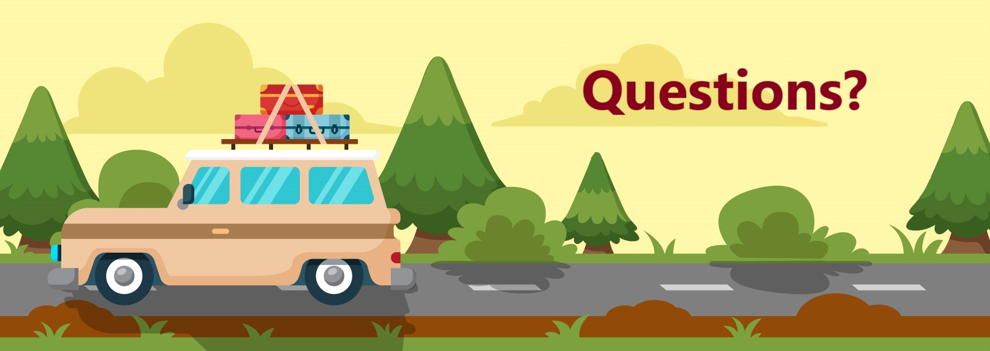

**NSA Naples School Liaison Officer**

[**NaplesSLO@eu.navy.mil**](mailto:NaplesSLO@eu.navy.mil)

**+39 081-811-6549 / DSN 629-6549**

[**www.navymwrnaples.com/programs/child-youth/school-liaison-officer**](http://www.navymwrnaples.com/programs/child-youth/school-liaison-officer)



March 9, 2021

1. <https://www.dodea.edu/parents/homeschooling.cfm>
2. <https://hslda.org/post/military-homeschooling-overseas>
3. <https://www.dodea.edu/Offices/PolicyAndLegislation/upload/DoDEA-AI-1375-01-Home-School-Students-Change-1.pdf>
4. <https://www.senato.it/documenti/repository/istituzione/costituzione_inglese.pdf>
5. <https://hslda.org/post/homeschooling-on-a-budget-or-no-budget>
6. <https://installations.militaryonesource.mil/military-installation/naval-support-activity-naples/education/education>
7. <https://www.homeschool.com/articles/Overseas/>
8. <https://hslda.org/post/what-are-homeschool-learning-groups>
9. <https://en.wikipedia.org/wiki/Umbrella_school>
10. <https://www.time4learning.com/vs/other-curricula.html>